Design Level Sequence Diagrams

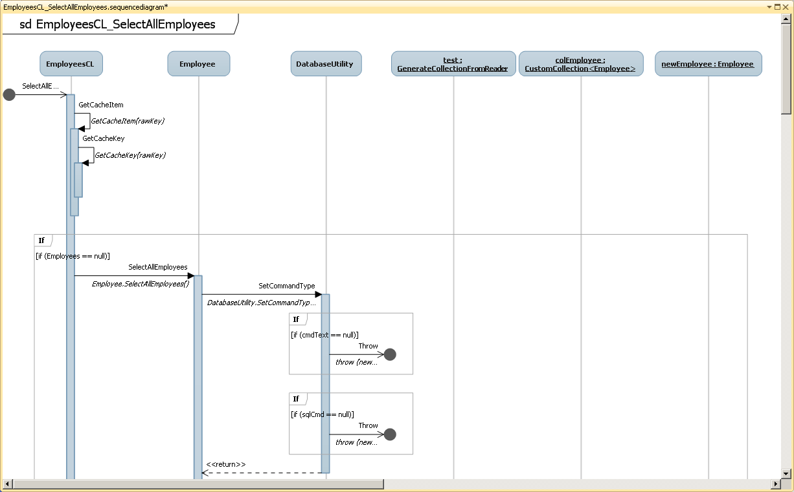

Figure : Diagram 1

*Note: this is just an example. Replace it with appropriate diagrams. Each use case should transform into a sequence diagram.*